**Photoelectric Effect Lab**

**Lab Partner Names**

Angela Zhang

Beth Momot

**Introduction**

In this lab, we studied the relationship between the stopping voltage and wavelength (and thus frequency) of light, as well as the relationship between intensity of light and both stopping voltage and photocurrent. Additionally, in the third exercise, we studied the photocurrent time response. In exercise 1, Einstein’s equation for the photoelectric effect:



was rearranged to give the equation for the linearly increasing function of V_stop:

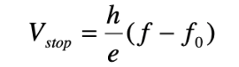

which should model the relationship between the stopping voltage and frequency, with *h* being Planck’s constant, *e* being electron charge (?), f being the frequency of light (which was varied in the experiment by using different wavelengths of light), and f_0 being the threshold frequency.

In exercise 2, it should be found that there is no relationship between the intensity of light and either stopping voltage or photocurrent, thus there is no equation modelling this ‘relationship’.

In exercise 3, the relationship should be modelled by the equation:

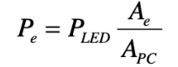

where P_e is the fraction of the power absorbed by each electron, P_LED is the electric power consumed by the oscillator-driven LED which is 60mW, A_e is the area taken up by the electron, and A_PC is the area of the photocathode.

**Methods**

For all of the exercises, the room’s lights were kept off to limit any light except for that coming from the lights in the experiment box from affecting the results.

For exercise 1, the equipment used is as follows: 8 LED bulbs (with the wavelengths 390 nm, 455 nm, 505 nm, 535 nm, 590 nm, 615 nm, 640 nm and 935 nm), a power supply, two boxes which together contained the phototube, and with the second box containing the photocurrent receptor, and the stopping voltage receptor, as well as 2 multimeters, and 4 wires (in addition to the phototube wire which was attached to the first phototube box).

The setup is shown in the photograph on the following page.

For exercise 2, the 8 LED bulbs were swapped out for an LED with variable intensity. The rest of the equipment and setup was the same as in exercise 1.

For exercise 3, the equipment used was the power supply, the first photocurrent receptor box, the oscilloscope, and the oscillator-driven LED. The setup is, again, pictured on the following page.

Setup for both exercises 1 and 2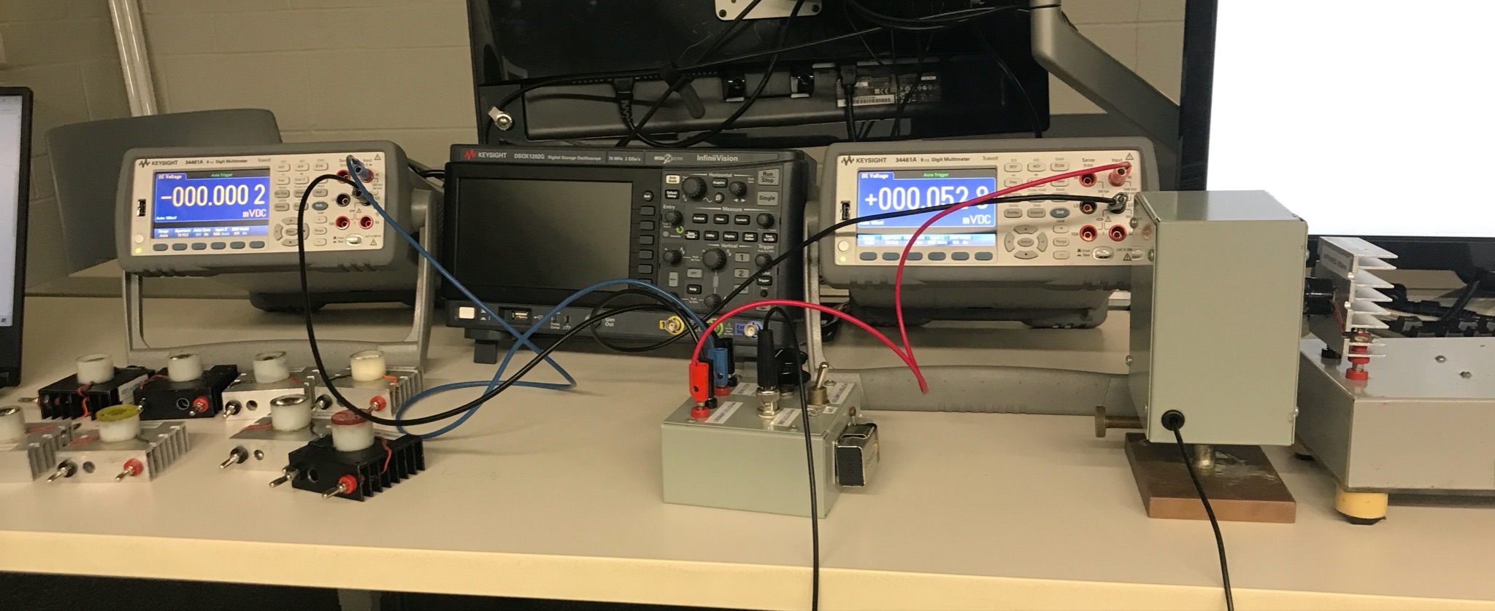

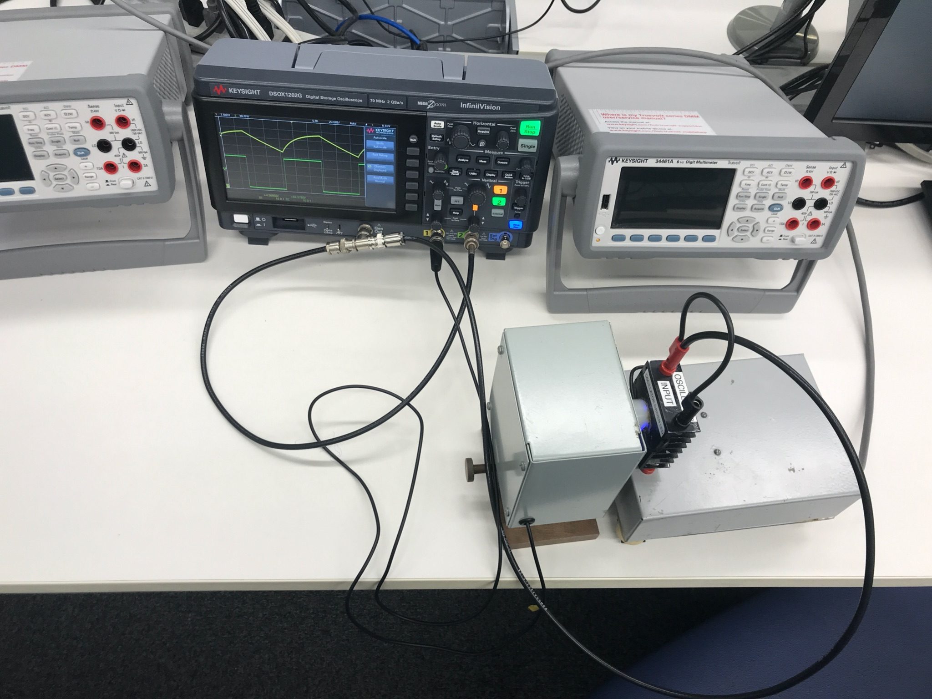

Setup for exercise 3

In exercise 1, the photocurrent was reduced to 0 with the potentiometer on, and the measurement of V_stop was taken for the first bulb (the infrared bulb). For this bulb, we also observed its ray using the infrared detection alignment card provided to make sure it was functioning properly. The measurement of V_stop was taken from the rightmost multimeter, which is found across the resistor in the circuit. This process (minus the use of the infrared detection card, of course) was repeated for all the remaining bulbs in the order of red, orange-red, amber, green, cyan, royal blue, and finally ultraviolet. We also observed the read on the other multimeter (which was measuring photocurrent) to ensure that it was close to 0, like it should be. For both exercise 1 and exercise 2, the measurements we recorded were what came up initially on the multimeter, to keep consistent, since there was generally a change in the V_stop over time, with it initially increasing and then decreasing. Since we took all of the measurements as immediately as possible, we are hoping these measurements will be more accurate to what they are supposed to be, or at least more consistent with each other.

In exercise 2, the setup of the circuit remained the same, but the different colored LED lights were swapped for the variable-intensity bulb provided. The measurements of V_stop were taken with the potentiometer still turned on, in order of increasing intensity (the light appeared to brighten as we turned the knob). Then, the potentiometer was switched off and the measurement of photocurrent was taken, again from lowest to highest intensity.

In exercise 3, the bulb and the first phototube receptor were hooked up to the oscilloscope as shown, with the wave generator being connected with a t-connector to both the oscillator-driven LED and the second channel of the oscilloscope. The power supply was connected to the first channel of the oscilloscope as well. Then Larry helped us to adjust the settings of the oscilloscope to smaller values of voltage in order to see the proper wave forms. Once this was done, we took the measurements of the periods and amplitudes of both the wavegen wave and the oscillator-driven LED wave.

**Results**

Table 1: Wavelength and Stopping Voltage Raw Data

| Wavelength (nm) | Wavelength Uncertainty (nm) | Stopping Voltage (VDC) |
| --- | --- | --- |
| 935 | 10 | 0.0000015 |
| 615 | 10 | 0.1406950 |
| 640 | 10 | 0.1027000 |
| 590 | 10 | 0.1124000 |
| 535 | 30 | 0.2830000 |
| 505 | 30 | 0.3655800 |
| 455 | 40 | 0.4195000 |
| 390 | 40 | 0.6815000 |

Table 2: Intensity and V_Stop for Variable LED

| Intensity (Integer Value Settings) | V_stop (VDC) |
| --- | --- |
| 1 | 0.3513 |
| 2 | 0.3633 |
| 3 | 0.3747 |
| 4 | 0.3875 |

Table 3: Intensity and Photocurrent for Variable LED

| Intensity (Integer Value Settings) | Photocurrent (mVDC) |
| --- | --- |
| 1 | 0.0035 |
| 2 | 0.0035 |
| 3 | 0.0035 |
| 4 | 0.0035 |

Table 4: Period of Oscillation from Oscilloscope

| Period of Oscillation (microseconds) | Amplitude of Oscillator-Driven LED (V) |
| --- | --- |
| 107.43 | 2.21 - 2.25 |

**Analysis**

Exercise 1:

The data for 935 nm wavelength of light produces a plot with a cutoff frequency less than the frequency corresponding to 935 nm wavelength of light. This means that the 935 nm wavelength of light has too little energy to make the photoelectric effect occur, therefore we have decided to omit it from data analysis.

The plot for data points except 935 nm is as follows:

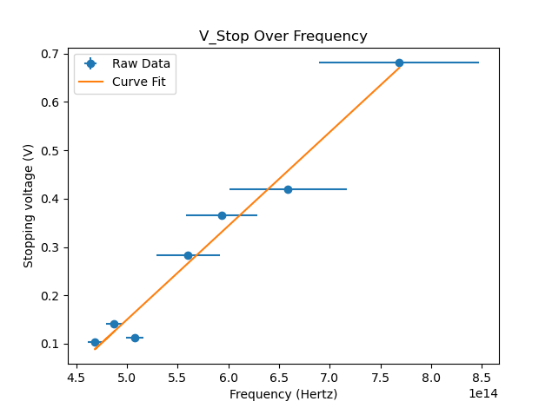

For Exercise 1, according to the plot we obtained, Planck’s constant is: 3.106*10^-34

土 3.502 * 10^-35 and the cutoff frequency is at 4.120*10^14 Hertz 土 7.8*10^14 Hertz. Uncertainties are found via our python program, where the uncertainty in Planck’s constant is found by summing the largest relative uncertainties, and uncertainty in cutoff frequency is found by summing the largest absolute uncertainties. The value we obtained for planck’s constant is about half the theoretical value of planck’s constant. Also, the reduced chi squared value for this plot is also very high: 1254.56, which is much greater than 1.

First, let us discuss the reduced chi squared value. Although having a high reduced chi squared value can mean the plot is not a good fit of the data, there are also two other reasons for this high reduced chi value. The main reason why the reduced chi squared value is so high is because the error passed into the calculation is only the y-uncertainty, which is uncertainty in precision for stopping voltage, which is very small. The bigger contributor to uncertainty in this experiment is actually in the x-axis, uncertainty in frequency. Reduced chi squared will not be a good measure for curve fit in this case where there are uncertainties in both axes.

Another reason is because the data point for the 590 nm wavelength of light does not fit the overall trend of the plot. If we take the data point out, we obtain a new plot as follows:

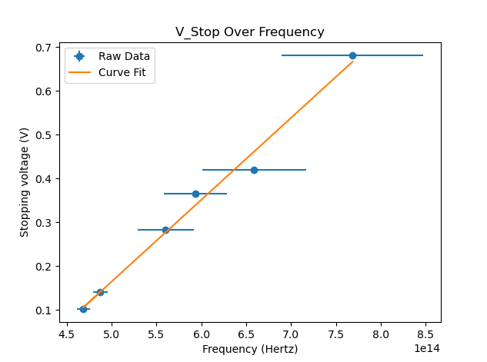

This new plot has a reduced chi squared value of 674.47, much less than the previous plot but still much greater than 1. We also obtain a new planck’s constant value of 2.996 * 10^-34 and cutoff frequency at 4.119 * 10^14 Hertz.

With these two plots, let us discuss the cutoff frequency. The cutoff frequency is consistent between both plots, producing the same value when rounding to 3 s.f., so for calculations we will use 4.12 * 10^14 Hertz as the cutoff frequency. Since E = hf, the corresponding threshold energy (work function of the metal) would be Planck's constant times this frequency. If we use the theoretical value of Planck’s constant, We obtain 2.73 * 10^-19 joules of energy to 3 s.f. as our work function. If we use the Planck’s constant we found via curve fitting our data, we obtain 1.28 * 10^-19 joules of energy to 3 s.f. as our work function.

The reason why our experimental Planck’s constant was smaller by a factor of 2 could be because of energy loss from our experimental setup. We assume that all energy inputted into the LEDs are outputted in the form of light, while in reality there may be energy loss in the form of heat. The fact that the trend is consistent supports this idea that there is some form of systematic error in our setup. Another reason why our experimental Planck’s constant could be off is because of the large uncertainty in data in higher wavelengths of light.

Exercise 2:

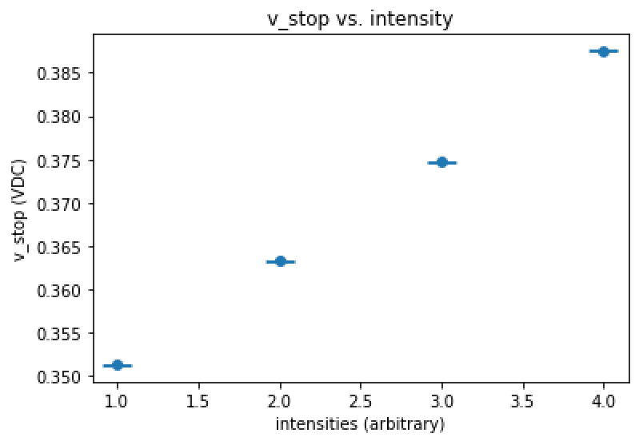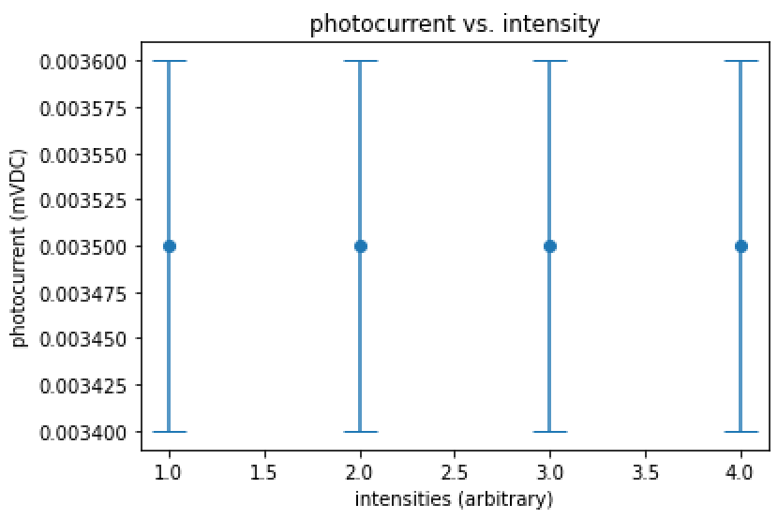

For this exercise, there should theoretically be no correlation between the intensity of the light and either the v_stop or the photocurrent. This is because the stopping voltage is related to the energy of the electrons which are incoming, and not on the number of electrons which are incoming (which is what intensity is related to). While the photocurrent was constant, showing a constant relationship between it and the intensity, as it should, the v_stop seems to have a relationship with the intensity of the light. As the intensity was increased (we know not by what factor or degree, as the intensities were arbitrary and not specified), the v_stop also increased, seemingly linearly (though, again, this is arbitrary since we do not know how the intensity was changing in respect to this ‘linear’ change in stopping voltage).

Given that the conditions in the room were kept the same, and that error due to fluctuations on the multimeters likely would not have shown a nearly perfectly linear relationship between the stopping voltage and the arbitrary intensities, we can conclude that perhaps there is something going wrong with the variable intensity bulb that we were using. Perhaps the wavelength of the light was also slightly changing with the intensity, resulting in a change in frequency and thus a change of energy. It was shown in exercise 1 that this in fact is exactly what would cause a change in the stopping voltage.

Exercise 3:

Using the work function (2.73 * 10 ^-19 Joules) found in Exercise 1 and values for power of the oscillator driven LED and area occupied by an electron and area of the photocathode found from the lab sheet, we will attempt to estimate the time response.

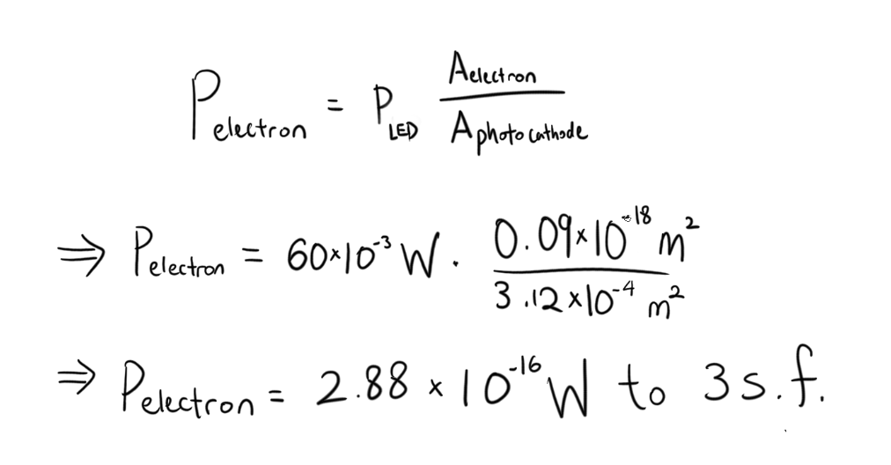



Each electron should receive 1.73 * 10^-17 Joules of energy per second. The time response would be the work function divided by the energy received by the electron. If we use the work function calculated using theoretical Planck’s constant, we get:

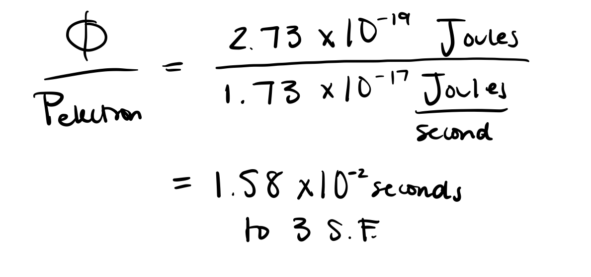

If we use the work function calculated using our experimental Planck’s constant, we get:

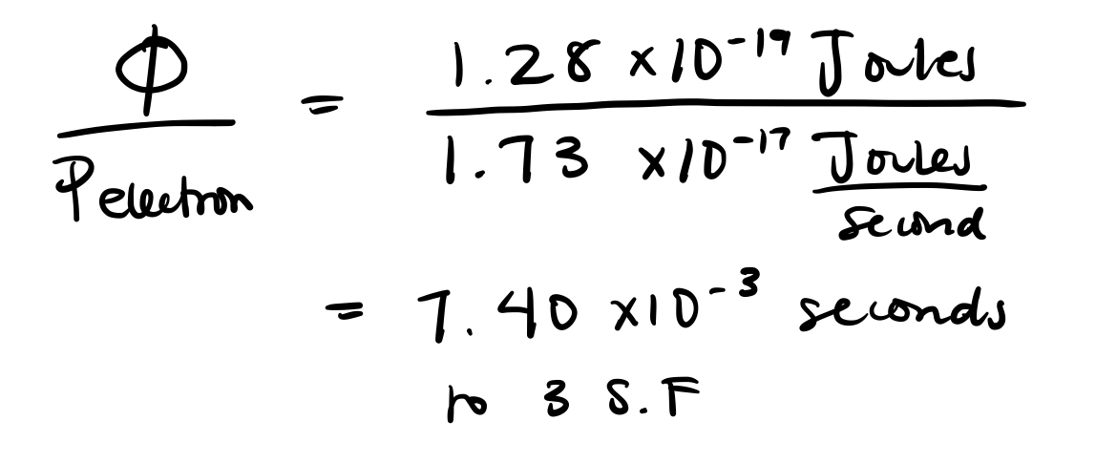

The estimated time response is either 1.58 * 10^-2 seconds to 3 s.f. or 7.40 * 10^-3 seconds to 3 s.f.. Experimentally, the period is found to be 1.07 * 10^-4 seconds, which is off from our estimated value by 2 or 1 orders of magnitude. The experimental time response is less than either the estimated time response, and there are some reasons why this is.

First of all, the estimated time response value may not be accurate due to some of the assumptions involved. We assume all 60mW that is inputted into the LED is outputted in the form of light. In reality, there would be some amount of energy loss in the LED in the form of heat and sound. However, this should’ve made the experimental time response longer, which was not the case, therefore we can deduce there is probably a larger uncertainty contributed by our experimental work function. In calculation we also assume our work function is accurate. Our work function itself probably is not accurate, given the corresponding planck’s constant value we found is smaller than the theoretical planck’s constant by a factor of ½, and that contributes to the larger inaccuracy. In reality, if we found the correct planck’s constant, we’d expect the work function to also be smaller.

**Conclusion**

For Exercise 1, we can conclude there is a linear relationship between V_stop (stopping voltage) and frequency. Our Planck’s constant is half of theoretical Planck’s constant, but our work function is reasonable compared to theoretical values. For Exercise 2, as theorized, there was no relationship between the photocurrent and intensity. However, there was a (seemingly) linearly increasing relationship between the stopping voltage and intensity. This is not right, but it could be due to a systematic error such as a slight change in the frequency of the light as its intensity was varied. For Exercise 3, the theoretical time response is longer than the experimental time response, but this may be due to errors in the work function found in Exercise 1.